<https://www.smartdraw.com/>

[The OSI Model – The 7 Layers of Networking Explained in Plain English (freecodecamp.org)](https://www.freecodecamp.org/news/osi-model-networking-layers-explained-in-plain-english/)

[Network Layering Diagram (smartdraw.com)](https://www.smartdraw.com/network-diagram/examples/network-layering-diagram/)

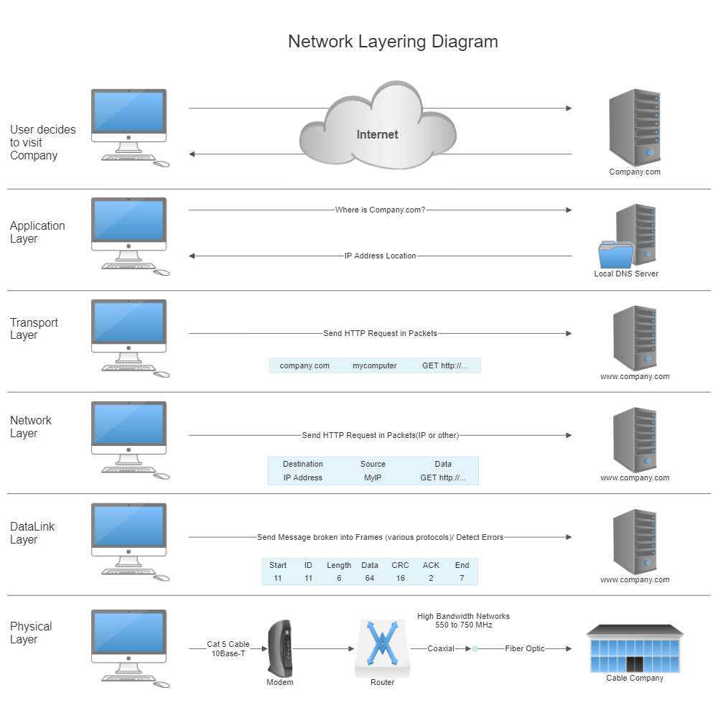

The OSI model consists of seven layers, each with a specific function and responsibility. The TCP/IP model consists of four layers, each corresponding to one or more layers of the OSI model. You can see how the layers are mapped in the diagram.

The seven layers of the OSI model are:

* **Physical layer**: This layer is responsible for transmitting individual bits from one node to another over a physical medium.
* **Data link layer**: This layer is responsible for providing error-free and reliable transfer of data frames between nodes on the same network.
* **Network layer**: This layer is responsible for routing packets from one network to another across multiple intermediate nodes.
* **Transport layer**: This layer is responsible for providing end-to-end communication between applications on different nodes.
* **Session layer**: This layer is responsible for managing the sessions between applications on different nodes.
* **Presentation layer**: This layer is responsible for transforming the data into a format that can be understood by the applications on different nodes.
* **Application layer**: This layer is responsible for providing services to the user applications on different nodes.

The four layers of the TCP/IP model are:

* **Network access layer**: This layer is equivalent to the physical and data link layers of the OSI model. It is responsible for transmitting bits over a physical medium and providing access to the network devices.
* **Internet layer**: This layer is equivalent to the network layer of the OSI model. It is responsible for routing packets across multiple networks using the Internet Protocol (IP).
* **Host-to-host layer**: This layer is equivalent to the transport layer of the OSI model. It is responsible for providing end-to-end communication between applications using the Transmission Control Protocol (TCP) or the User Datagram Protocol (UDP).
* **Application layer**: This layer is equivalent to the session, presentation and application layers of the OSI model. It is responsible for providing services to the user applications using various protocols such as Hypertext Transfer Protocol (HTTP), Simple Mail Transfer Protocol (SMTP), File Transfer Protocol (FTP) and so on.